Press Facts
Complete machining of turbine rotors of up to 140 tons weight

Heinrich Georg Maschinenfabrik:
The “GEORG” machine cuts machining times at Doosan Škoda Power by 50 percent
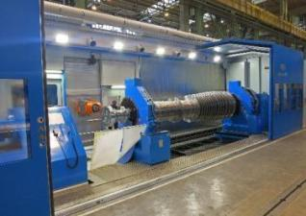
Integrated measuring systems dramatically reduce set-up and idle times.
Kreuztal, Germany, April 3, 2017 On February 28, Doosan Škoda Power officially inaugurated the new ultraturn MC horizontal machining center supplied by GEORG at its Pilsen works in the Czech Republic. Doosan Škoda Power will use the new machine primarily for machining turbine rotors of up to 140 tons weight. This machining center is the third of its kind in the world to combine turning, drilling, milling, grinding and measuring of extremely large parts in one unit.
The new machine is designed to handle workpieces with diameters of up to 3,500 mm and lengths of up to 12,000 mm. It is the third ultraturn MC unit in operation worldwide. Siemens has been using a similar machine in Berlin since 2016 and another one, in operation in Russia, machines gas compressors.
In the past, the Pilsen works used to machine the turbine rotors in three steps – requiring three separate machines: first, all the rotors’ bearing journals were turned, then the fir-tree blade slots were milled and, finally, the balancing holes and the coupling holes were drilled. In contrast, the new machine, which everyone at Doosan Škoda Power simply calls “GEORG”, performs all these three process steps in one sequence, i.e. the work pieces do not have to be re-clamped or transferred in any way. What is more, the machining centers of the ultraturn MC series are the first of their kind in the world designed to measure extra large workpieces with highest precision directly in the machine.
450 hours of machining time saved
According to Jaroslav Milsimer, Director of turbine manufacturing at Doosan Škoda Power, the new machine has substantially strengthened the market position of the Pilsen works: “In the first place, ordering the new machine from GEORG was an investment in quality. Besides that, we are also saving a lot of machining time, namely 30 percent during turning and 50 percent during drilling and milling. The overall machining time for regular rotors has thus decreased from about 1,000 down to 550 hours. Thanks to the new machining center, we are now the internationally leading manufacturer of large turbine rotors.”
Jan Ebener, Head of Sales machine tool division at GEORG, explains why the customer decided to invest in an ultraturn MC machine: “No one else in the world combines the processes of milling, turning, drilling and grinding for parts of truly gigantic dimensions as smartly within one unit as we do. Apart from that, we are the only ones to integrate a high-precision measurement system for such enormous workpieces in the same machine.”
For universal use
Doosan Škoda Power intends to use the new machining center mainly for the manufacture of turbine rotors. Nevertheless, the machine has been designed for universal use. Milsimer sees new markets opening up for his company: “The new facility enables us to also produce rotors for generators, rolls for the paper industry, large-diameter drive shafts and even crankshafts.“
Dr. Wieland H. Klein, Managing Director of GEORG’s machine tool division, takes pride in the fact that a medium-sized business from the German Siegerland region has supplied a machine that will secure the future of Doosan Škoda Power’s production site in Pilsen: “The works will be able to react flexibly to changing conditions and remain competitive in the future because the GEORG machine can be easily adapted to changing requirements or even completely new ones. This will require nothing but minor modifications. New machining tools or new steady rests can be added without a hitch. Shortly, our customer will use the machine also for grinding.
580 words including introduction
About Heinrich Georg Maschinenfabrik
GEORG is a business partner worldwide well-reputed for reliable and powerful high-tech mechanical engineering solutions. The company’s cutting-edge finishing lines and machine tools as well as production lines, machines and equipment for the transformer industry are in operation in numerous renowned companies around the world.
The family business, now in its third generation, supplies a wide range of products to most diverse markets and customer segments. All three GEORG divisions are supported by the company’s own manufacturing facilities at the headquarters in Kreuztal, Germany. The GEORG corporate services division completes the portfolio with a wide range of value adding services. The company maintains a worldwide network of sales and service branches to be within easy reach for its international customers.
GEORG machine tools
The GEORG machine tool division develops and manufactures advanced value-adding machine tools for turning, drilling, milling and grinding in close cooperation with its customers and optimally tailored to their individual requirements.
www.georg.com
Contact:  Heinrich Georg GmbH Maschinenfabrik  machine tool division  Jan Ebener  Langenauer Straße 12  D-57223 Kreuztal/Germany  Fon: +49.2732.779-338  Fax: +49.2732.779-327  www.georg.com  E-mail: wzm@georg.com | Press contact:  VIP Kommunikation  Dr.-Ing. Uwe Stein  Dennewartstraße 25-27  D-52068 Aachen/Germany  Fon: +49.241.89468-55  Fax: +49.241.89468-44  www.vip-kommunikation.de  E-mail: stein@vip-kommunikation.de

Figures:

→ Download of high resolution photos: Please click here: Press Photos Georg
Fig. 1: The new GEORG ultraturn MC machining center in the Pilsen works of Doosan Škoda Power.  File name: Georg IMG_4383 a.jpg | 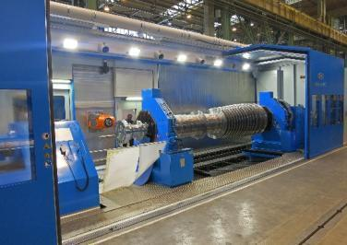
Fig. 2: Wieland H. Klein, Managing Director of the GEORG machine tool division (left) and Jaroslav Milsimer, Director of Turbine Manufacturing at Doosan Škoda Power, during the inauguration ceremony for the new machining center.  Klein brought a sculpture of a traditional mineworker from the Siegerland region as a present for the host.  File name: Georg DSC_0142 a.jpg | 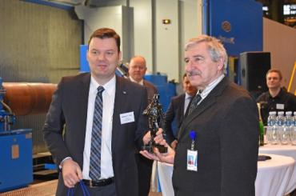
Fig. 3: Dr. Klein and Director Milsimer cutting the ribbon  File name: Georg IMG_8922 a.jpg | 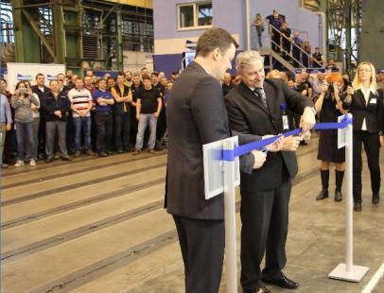
Fig. 4: The hydrostatic steady rests are additionally fitted with a hydraulic clamping device.  File name: Georg IMG_8878.jpg | 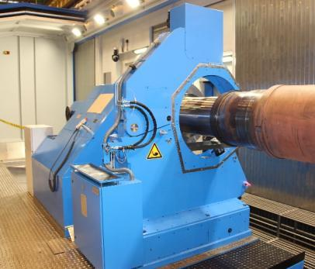
Fig. 5: A first for machining centers handling workpieces of very large dimensions: the machine is completely housed and the emulsion mist is extracted via an integrated suction system. As a result, virtually no vapors escape into workshop and the noise level is significantly reduced.  File name: Georg IMG_8869.jpg | 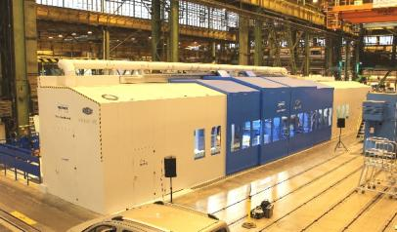
Photo credits: Figures 1 and 2: Doosan Škoda Power
Figures 3 to 5: Heinrich Georg Maschinenfabrik

