Press Facts
Rough and Finish Machining of Profile Rolls in the Steel Industry

Heinrich Georg Maschinenfabrik delivers the fourth Roll Lathe to Trinec
Kreuztal, Germany, March 1, 2016 Last December, Heinrich Georg GmbH Maschinenfabrik received an order for the delivery of a roll lathe for up to 10 t of workpiece weight from Czech company Strojirny a Stavby Trinec, a.s. This is already the fourth machine ordered in Kreuztal by the subsidiary of Třinecké železárny a.s. since 1996.
The new Roll Lathe Type GEORG ultraturn 900 R will be used for new machining and finishing of profile rolls, by means of which Třinecké železárny mainly produces round profiles, flat sections, angle profiles as well as reinforcing steel for the construction industry.
The machine is designed for rolls with a diameter of up to 900 mm and a weight of up to 10 t and a center width of 2.500 mm. The tool holder in slide design with one tool slide ensures a safe transmission of highest cutting forces.
Already in 1996 and 2003 GEORG delivered two machines for workpiece weights of up to 40 t, in 2004 another machine for rolls up to 10 t. The new machine completes the roll workshop equipment, having four GEORG machines in operation in the future. The production capacity expansion makes this investment necessary. All four machines are fully hydrostatic guided, a concept which GEORG generally applies for all its roll lathes. The biggest machines of the ultraturn range can handle workpieces with weights of up to 300 t and more. The machine enables heavy roughing with high cutting parameters as well as finishing with highest demands on accuracies. In this way, the customer additionally saves time for workpieces setup.
In contrast to more simple linear-guided or slide guided machines there are almost no running costs for loss lubrication or guiding elements exchange as it is the case for hydrostatic guided machines. Furthermore, based on the design principle, these machines achieve the same accuracy as new machines, even after heavy use in a roll shop for decades. By receiving this order, Jan Ebener, Head of Sales for GEORG´s Machine Tool Division, believes the concept of hydrostatic guided machines to be proven:
“Besides the quality of our machines, our customers obviously also appreciate their efficiency. Thus, we have succeeded against strong domestic and foreign competitors. Lathes equipped with the hydrostatic and wear-free guideways are more expensive to purchase, but more efficient and economically over the years and decades.”
GEORG will deliver the machine in autumn 2016.
2,400 characters including introduction and blanks

Background:
GEORG- Roll Lathes cost advantages
The extremely robust construction of the GEORG Roll Lathes reflects its advantages after only a few years of operation time: In comparison to lighter or not fully hydrostatic machines, they generate much lower costs for the operating time duration. The lifecycle costs are reduced by high maintainability and low operating costs as well as by using wearfree hydrostatic guideways or high availability of stable and proven components. Due to wide machine beds and overall more stable machine, the maintenance intervals are extended and thus lead to much lower operating costs. Shorter machining times increase the productivity and hence reduce the unit prices.

Contact:  Heinrich Georg GmbH Maschinenfabrik  Machine Tool Division  Langenauer Straße 12  57223 Kreuztal/Germany  Tel.: +49. 2732 779-306  Fax: +49. 2732 779-316  www.georg.com  E-Mail: wzm@georg.com | Press contact:  VIP Kommunikation  Dr.-Ing. Uwe Stein  Dennewartstraße 25-27  52068 Aachen/Germany  Tel.: +49.241.89468-55  Fax: +49.241.89468-44  www.vip-kommunikation.de  E-Mail: stein@vip-kommunikation.de

Figures:

Download of high resolution image files: press photos Georg
Fig. 1: The headstock of a GEORG Roll Lathe Type ultraturn 900 R.  File name:  GEORG ultraturn R Spindelstock.jpg | 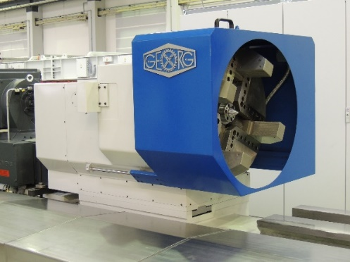
Fig. 2a: Already in use in Trinec: A GEORG Roll Lathe Type ultraturn 1500 R for profile rolls.  File name:  GEORG Georg P1010669.jpg | 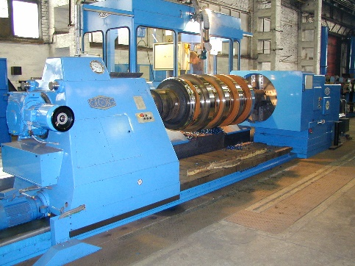
Fig. 2b: Already in use in Trinec: A GEORG Roll Lathe Type ultraturn 900 R for profile rolls  File name:  Georg P1010577a.jpg | 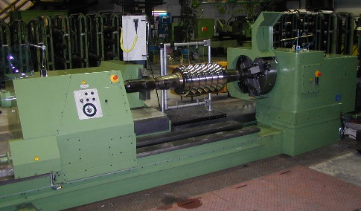
Fig. 3: Faceplate of a GEORG ultraturn 900 R with mechanical clamping spindles.  File name:  GEORG ultraturn R Planscheibe.jpg | 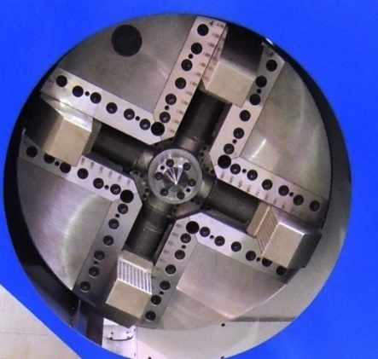
Fig. 4: Detail of a tailstock of a GEORG ultraturn 900 R with live center and revolving quill.  File name:  GEORG ultraturn R Reitstock.jpg | 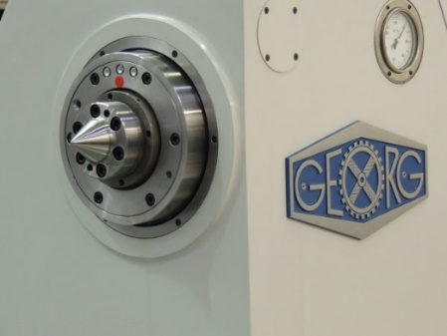
Picture credits:
Fig. 1, 3 and 4: Works photos Heinrich Georg GmbH Maschinenfabrik
Fig. 2a and 2b: Works photos Strojirny a Stavby Trinec, a.s.

