Premiere at ALUMINIUM 2018
Machining of high-precision aluminium plates

Heinrich GEORG Maschinenfabrik:
Milling machine for aluminium plates sets new standard
Highly automated system cuts machining time by more than 30 percent.
Kreuztal, Germany, September 3, 2018 At the Aluminium 2018 show in Düsseldorf, GEORG is going to introduce its new portal-type milling machine – GEORG ultramill – for high-precision aluminium plates. With an accuracy of surface parallelism of +/- 0.05 mm achieved by this machine, GEORG is setting a new standard. At the same time, production throughput increases significantly as GEORG has doubled the machining speed and implemented a high degree of automation compared to machines generally in use so far.
The new machine mills the surfaces of up to 3,000-mm-wide aluminium plates with a unique precision of surface parallelism. While +/- 0.1 mm used to be the industry standard, the new machine achieves an accuracy of 0.05 mm. In a single run – without rough and finish machining – it provides a surface roughness R_{a} between 0.28 and 0.4 µm.
With milling speeds of up to 4,000 mm/min and feed rates of up to 60 m/min, machining times are more than 30 percent shorter than those of conventional machines. This is enabled, among others, by the extraordinarily high milling unit drive power of 200 kW.
Also the high degree of machine automation has contributed to the marked increase in throughput: The plates are automatically fed into the machine, held firmly down by a vacuum clamping table, automatically turned over when the top side has been milled and again held down automatically by the vacuum clamping table while the other side is being milled.
Dr. Wieland Klein, Head of GEORG’s machine tools division, has already received feedback from users of the new machine. “First users of the machines have been reporting dramatic reductions in machining and non-productive times. And the product quality has become much better. Our preloaded and backlash-free, guideways guarantee highest precision and long-time accuracy of the machine.”
GEORG measures the plate thickness in three tracks by means of laser triangulation. The integrated GEORG Maintenance System (GMS) continuously monitors the complete machine, among others also the tool wear. The machine data is transferred to the host computer, linking the machine with the plant-wide process network.
At the trade fair, GEORG will also showcase a new portal-type milling machine that machines all sides of aluminium slabs with the slabs having to be turned only once during the process. Also this machine excels in terms of precision and provides very short machining times.
390 words
Heinrich GEORG at ALUMINIUM 2018 in
Düsseldorf, Germany,
9 - 11 October 2018
Hall 9, Stand D40
About Heinrich GEORG Maschinenfabrik
GEORG is a worldwide well-reputed partner for reliable and powerful high-tech engineering solutions. The company’s cutting-edge finishing lines and machine tools as well as production lines, machines and equipment for the transformer industry are in operation in numerous renowned companies around the world.
The various product areas of the family-owned company, which employs more than 480 people and is now in its third generation, cater to most diverse markets and companies throughout the world.
The divisions GEORG Finishing Lines, GEORG Transformer Lines and GEORG Machine Tools are supported by the company’s own manufacturing facilities at the headquarters in Kreuztal, Germany. The company maintains a worldwide network of sales and service branches to be within easy reach for its international customers.
GEORG machine tools
The GEORG machine tools division develops and manufactures advanced value-adding machine tools for turning, drilling, milling and grinding in close cooperation with its customers and optimally tailored to their individual requirements.
Contact:  Heinrich Georg GmbH Maschinenfabrik  Thomas Kleb  Leiter Marketing & Kommunikation  Langenauer Straße 12  D-57223 Kreuztal/Germany  Fon: +49.2732.779-539  www.georg.com  E-mail: thomas.kleb@georg.com | Press contact:  VIP Kommunikation  Dr.-Ing. Uwe Stein  Dennewartstraße 25-27  D-52068 Aachen/Germany  Fon: +49.241.89468-55  Fax: +49.241.89468-44  www.vip-kommunikation.de  E-mail: stein@vip-kommunikation.de

Figures:

High-resolution image files are available for downloading at: Photos Georg
Fig. 1: The new machine mills the surfaces of up to 3,000-mm-wide aluminium plates with a precision of +/- 0.05 mm.  File name:  Georg_Ultramill_P1_A4_300dpi_Final.jpg | 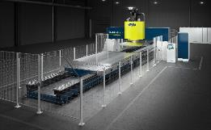
Fig. 2: Milling heads are available in diameters of up to 3,200 mm.  File name:  Georg_Ultramill_P2_A4_300dpi_Final.jpg | 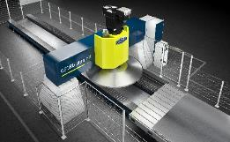
Fig. 3: The milling head operates with a drive power of up to 200 kW.  File name:  Georg Platten-Fräsmaschine 2.png | 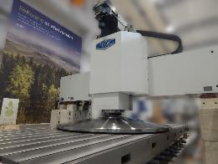
Fig. 4: Mobile user terminals provide much operating flexibility.  File name:  Georg DSCN4166.jpg | 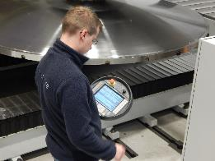
Photos provided by Heinrich Georg Maschinenfabrik

