Press Facts
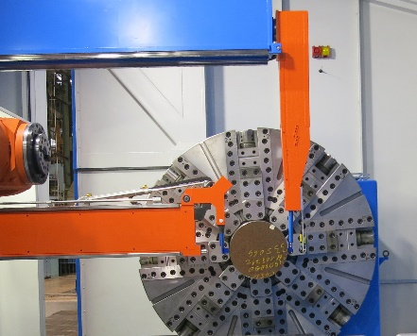
Complete machining of large turned parts

Heinrich GEORG Maschinenfabrik:
Two-point measurement reduces non-productive times
Quality control integrated into the production process makes time-consuming manual measurements superfluous.
Kreuztal/Germany, July 27, 2017 At EMO, GEORG will be presenting the integrated two-point measurement system for horizontal machining centers of its ultraturn MC series. These machines process workpieces weighing 10 tons and more and with diameters of 1,000 mm upwards. No other manufacturer in the world combines machining and measuring in a single unit of such size.
With the two-point measurement, GEORG has for the first time integrated quality control directly into the manufacturing process: ultraturn MC is worldwide the first series of machining centers for large turned parts in which the diameters of the workpiece are not measured with just one probe, as has been common practice so far. Instead, GEORG uses a travelling two-point measuring system attached to the frame, which automatically measures the workpieces directly in the machine with two opposing probes. This technique ensures high precision and high reproducibility.
ultraturn MC machines are used among other things for the complete machining of turbine and generator rotors as well as crankshafts.
While a measuring team would need several hours to manually measure the diameters or the axial run-out of workpieces on the machine, the measurement with the integrated two-point system is completed after just a few minutes. By integrating this function into the machine, GEORG is a worldwide pioneer.
The two-point measuring system which GEORG is demonstrating at the trade fair on a machining center of the ultraturn MC series is also applicable to the company’s classic lathe series for roll and turbine rotor machining. Furthermore the system can be retrofitted to existing lathes – to those made by GEORG or other manufacturers. Just recently, GEORG has successfully retrofitted a two-point measuring system to a lathe in operation for several years at Siemens in Mülheim/Germany.
Jan Ebener, sales manager for machine tools at GEORG, explains the great economic benefits of the integrated measurement: “Experience gained from the operation of the first systems using our two-point measurement technique shows that not only the dimensional precision of the workpieces is increased but that also the overall machining times are markedly reduced. This is because the new measurement technique drastically reduces non-productive times.”
Like the large machines of the ultraturn MC type, designed to machine parts of up to 250 t weight, also the smaller ones are based on the classic GEORG concept: robust cast construction - instead of the frequently common welded construction – and hydrostatically guided axles. The result: high precision in machining, low maintenance and long lifetime.
2,650 characters including introduction and blanks
Heinrich GEORG at EMO 2017 in Hanover, Germany
18 - 23 September 2017
Hall 26, stand B12
About Heinrich Georg Maschinenfabrik
GEORG is a business partner worldwide well-reputed for reliable and powerful high-tech mechanical engineering solutions. The company’s cutting-edge finishing lines and machine tools as well as production lines, machines and equipment for the transformer industry are in operation in numerous renowned companies around the world.
The family business, now in its third generation, supplies a wide range of products to most diverse markets and customer segments. The divisions GEORG finishing lines, GEORG transformer lines and GEORG machine tools are supported by the company’s own manufacturing facilities at the headquarters in Kreuztal, Germany. The GEORG corporate services division completes the portfolio with a wide range of value adding services. The company maintains a worldwide network of sales and service branches to be within easy reach for its international customers.
GEORG machine tools
The GEORG machine tools division develops and manufactures advanced value–adding machine tools for turning, drilling, milling and grinding in close cooperation with its customers and optimally tailored to their individual requirements.
Contact:  Heinrich Georg GmbH Maschinenfabrik  Thomas Kleb  Manager Marketing & Kommunikation  Langenauer Straße 12  57223 Kreuztal/Germany  Fon: +49.2732.779-539  Fax: +49.2732.779-39171  www.georg.com  E-mail: thomas.kleb@georg.com | Press contact:  VIP Kommunikation  Dr.-Ing. Uwe Stein  Dennewartstraße 25-27  52068 Aachen/Germany  Fon: +49.241.89468-55  Fax: +49.241.89468-44  www.vip-kommunikation.de  E-mail: stein@vip-kommunikation.de

Figures and captions:

Download of high-resolution photos:

Click here: Pressefotos Georg
Fig. 1: The two opposing probes detect the diameter of the rotating part with high precision.  File name:  Georg Zweipunkt-Messung.jpg | 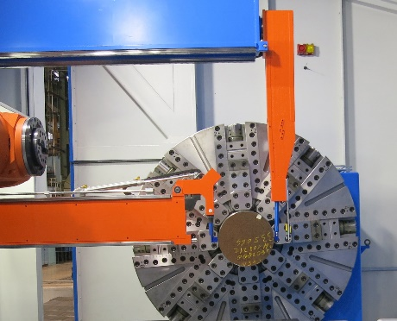
Fig. 2a: The measuring devices eliminate the time-consuming manual measurement.  File name:  Georg_Ultraturn_Real_Messen_5.jpg | 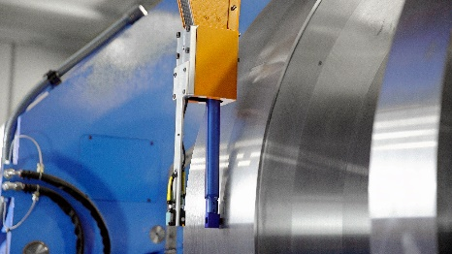
Fig. 2b: The measuring devices eliminate the time-consuming manual measurement.  File name:  Georg_Ultraturn_Real_Messen_6.jpg | 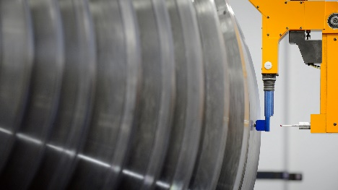
Image credits: Heinrich Georg Maschinenfabrik

