Press Information
Roll grinding machines for the steel industry
Heinrich Georg Maschinenfabrik:
A further roll shop for the Baowu Group
Grinders for the world’s most advanced roll shop
Kreuztal, Germany, 27 November 2023 The Chinese Baowu Group has placed an order with GEORG to supply four GEORG ultragrind roll grinding machines for a fully automatic roll shop serving the company’s cold rolling mill in Wuhan, in the province of Hubei. As early as in 2019, GEORG already supplied five roll grinders as part of a works expansion at Baowu’s facilities in Zhanjiang in the Guangdong Province.
The recent order from Baosteel Wuhan Iron and Steel Co., Ltd. comprises three GEORG ultragrind SG-2 grinding machines for work rolls and one GEORG ultragrind 25 machine capable of processing both back-up and work rolls.
All four machines will operate within the automatic zone of the roll shop where all logistical and machining processes are performed without any manual intervention. The machines will be integrated into the existing roll shop management system and centrally operated from a common control room. Therefore, GEORG will equip the grinders with GEORG smartcontrol, a machine control system that ensures smooth integration into fully automatic operating environments. The GEORG machines for the Zhanjiang works were also supplied complete with GEORG smartcontrol and have proved highly productive and efficient in operation. With its user-friendly HMI, the system forms an efficient link between the machines and the operators. Additionally, innovative measuring and inspection systems guarantee optimal quality of the reconditioned rolls.
After activation of the automatic control system, all of the activities related to the reconditioning processes in the roll shop can be performed with a few operators only.
In addition to excellent technology and high efficiency of the machines, maintaining direct and personal contact with the customers is very important for Patrick Neuser, sales engineer for roll grinding machines at GEORG: “Our customer’s aim is to operate the most advanced roll shop in the world. We look forward to supplying the key components for this groundbreaking project. Obviously, the positive experience made by our customer with our previously supplied machines for the Zhanjiang project was the reason for Baowu to prefer our products to those of other market players. We believe that, in addition to the premium quality of our machines, the high availability of our team and our personal on-site service played a role in our customer’s decision in favour of GEORG.”
380 words
Contact at GEORG:  Heinrich Georg GmbH Maschinenfabrik  Thomas Kleb  Leiter Marketing  Langenauer Straße 12  D-57223 Kreuztal/Germany  Phone: +49 2732 779-539  www.georg.com E-mail: thomas.kleb@georg.com | Contact for the media:  VIP Kommunikation  Dr.-Ing. Uwe Stein  Dennewartstraße 25-27  D-52068 Aachen/Germany  Phone: +49 241 89468-55  www.vip-kommunikation.de  stein@vip-kommunikation.de

Figures and captions
Download press photos Heinrich Georg

Fig. 1: The GEORG ultragrind roll grinding machines for the Baowu Group will be equipped with GEORG smartcontrol.  File name:  GEORG ultragrind Bao01.jpg | 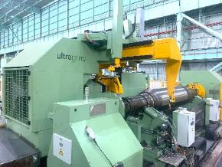
Fig. 2: Since 2019, five GEORG ultragrind roll grinders have been successfully in use in the roll shop of Baowu Group’s rolling facilities in Zhanjiang.  File name:  Georg Rollshop5.jpg | 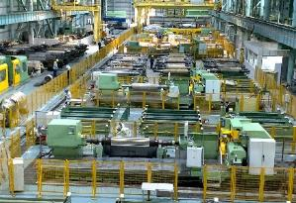
Image rights: Heinrich Georg Maschinenfabrik
About Heinrich GEORG Maschinenfabrik
GEORG is the specialist for sophisticated and economical solutions in coil processing and roll grinding, combining classic mechanical engineering with intelligent process optimization and service solutions. The advanced coil processing lines, the world's leading production lines for the transformer industry and the modern roll grinding machines are used in renowned companies around the world. Not least because of their high degree of automation, GEORG machines make an important contribution to process optimization and thus to the economic success of customers. The product range is complemented by a series of consulting, planning and service offerings and is used for demanding and standardized applications.
The third-generation family-run company with over 500 employees and worldwide sales and service branches serves the energy, mobility and industrial markets in particular. GEORG stands for responsible action and focuses on resource conservation and energy efficiency.
For more information, please visit georg.com

